YMCA Cape Cod David Brazil
Memorial Kids Triathlon

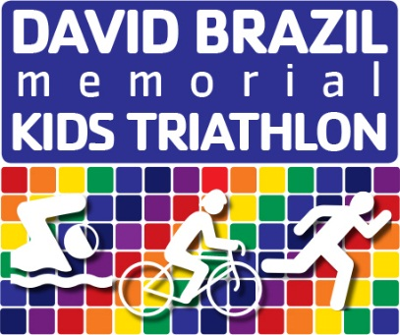
When: August 2, 2014 from 2:00 pm - 7:00 pm (rain date August 3, 2014)
Where: Camp Lyndon, 117 Stowe Road, Sandwich, MA
Join us for this fun event that introduces the sport of triathlon to children while honoring the memory of David Brazil. The event will not be timed, insuring there are only winners! Each participant will receive a finisher medal after completing the course. The triathlon consists of a pond swim, mountain bike ride, and trail run with approximate distances determined by participant age as follows:
- 8 to 10 years old: 25 yard swim, 1 mile bike, 1/4 mile run
- 11 to 13 years old: 50 yard swim, 2 mile bike, 1/2 mile run
- 14 to 16 years old: 100 yard swim, 3 mile bike, 1 mile run
Not only is the event fun, but proceeds beyond registrations fees go directly to a scholarship for high school seniors in David’s name, as awarded by the DBMKT Planning Committee. David Brazil was a triathlete who passed away unexpectedly of a heart attack in 2012 at the age of 45. He left behind his wife, Beth, and his two children who at the time, were ages 8 and 10. Beth founded the YMCA Cape Cod David Brazil Memorial Kids Triathlon as a way to remember Dave and pass on his love of family and triathlon to future generations.
Registration Information: Registration costs: 1 participant $15, 2 participants for $25, 3 or more participants for $35 (maximum $35 per family). You may also make an additional donation that will be deposited into the scholarship fund. Make checks payable to YMCA Cape Cod DBMKT.
Child’s name (First, Last): ______________________________________________________
Race day age: ________________________________________________________________
Tshirt Size: Youth SM MED LG Adult SM MED LG
Child’s name (First, Last): ______________________________________________________
Race day age: ________________________________________________________________
Tshirt Size: Youth SM MED LG Adult SM MED LG
Child’s name (First, Last): ______________________________________________________
Race day age: ________________________________________________________________
Tshirt Size: Youth SM MED LG Adult SM MED LG
Additional contribution to the scholarship fund: ______________________________________
Total amount enclosed: _________________________________________________________
□ By checking here I agree to the terms and conditions of the YMCA Cape Cod waiver (see reverse side).
Mail registration and check to: YMCA Cape Cod, 2245 Route 132, West Barnstable, MA 02668
Questions? Contact Steven Wolfe 508-362-6500 or swolfe@ymcacapecod.org

